Abstract:

Studying on EMG signals based armature control. Furthermost aim is to reduce the noise, electrical and mechanical disturbances present in the EMG signal to obtain a properly applicable signal waveform & proper Kalman-filter, which supports in filtering the signal and the entire Data frame and the most significant contribution in voltage regulation, it helps in preserving the useful frequency components increases the stability of the armature and smoothing it, and provides a better and much more efficient stability analysis. Minor statistical analysis is also used.

The entire mathematical formulations are simulated using Matlab and Python.

1. Introduction:

As with all research reports and surveys on medical prosthetics explains to me that prosthetics are in significant role of human rehabilitation and human growth in everyday life, but after a vast survey and specific experiments we concluded that there are undoubtedly significant issues which are still not appropriately solved and are creating problems to the patients, among them some are

(1)-Noise in EMG signals due to different external and internal factors

(2)-Electrical disturbances majorly voltage errors due to many reasons such as improper placements of EMG leads, circuit problems, temperature, etc

(3)-Mechanical disturbances majorly instability due to high or low resistance, improper working of sensors which further leads to electrical instability.

Due to these problems cases are noticed in which there is improper functioning of the prosthetic and high prone to damage in short periods and impacts the movements poor balance, instability or fear of falling further generating fatigue and reducing mobility, such as the complexity of the nonlinear system, unavailability of an accurate and precise mathematical model.

Here in this article our main aim is to work on all these unexplored problems and to provide a proper realistic solution with the help of control system algorithm and specific computational algorithm with an advance designed optimistic white line Kalman-filter algorithm and its proper application to design the best fit and satisfactory integration of EMG controlled armature kinematics to reduce its complexities and increase its stability to the best possible and to increase its self-automated balance as much as possible. Hence complete integration is so can be obtained by a joined, coordinated style of the hand, optimization that considers as targets not solely the intrinsic performance of every single scheme, however, the overall compatibility is final aim. Despite the intensive efforts being created with entirely different techniques mentioned higher than, finding an appropriate algorithm that permits the decoding of arm movement exploitation surface myogram with high efficiency was hardly achieved. One recent study that used the Kalman filter with a myogram signal to rewrite the movement resulted in rather poor performance with their planned setup. Hence An experimental model was built and tested for accuracy and repeatability.

1. System Modeling:

The EMG data is obtained from the user, the data is sampled according to our requirement performed Fast Fourier Transform and shifting the zero components towards the center, then after we generate the bandpass filter according to our required cut-off frequency, performing the inverse shifting and inverse Fourier transform and passing through the band-pass filter of required frequency’s provides us the best fit filtered EMG signal, Feature extraction - MAV using convolution then after theoretical response and adjusting it.

The processed signal is passed through Motor Control, further computed through control and computational algorithm, a major part of which is for stability analysis using frequency domain analysis and bode plot algorithmic analysis which gives us the proper system model index and parameter’s and there amplitude is for the best fit model. The voltage obtained may face different fluctuations for different reasons such as circuit disturbance, improper placements of EMG leads, temperature. Mechanical disturbances majorly instability due to high or low resistance, improper working of sensors which further leads to electrical instability. The voltage readings are passed through the Kalman filter, and some statistical analysis finds the most optimum averaging factor for each following state. Also somehow remembers a little bit about the past states. Hence a mathematical model for the best fit voltage is obtained by making use of the available voltage’s. As the individual with such devices must be able to generate such signals purposely. It is additionally necessary that the interface adopted (the Human-Machine Interface – HMI) will "understand" and method such signals, setting the command that higher fits the would like of the individual. Then, associate degree HMI is accustomed to improve the capability of movement of people with more accuracy and fewer efforts.

The kinematic signal foreseen from the decoder was filtered employing a moving average with a backward time window of 180 ms to enhance movement smoothness towards on-line automaton management.

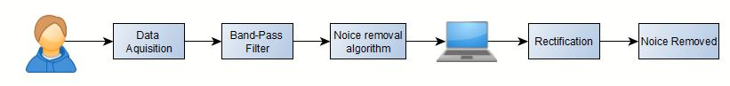

1. -Signal processing and noise removal model

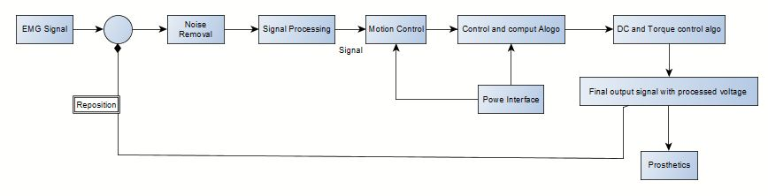

1. -System model

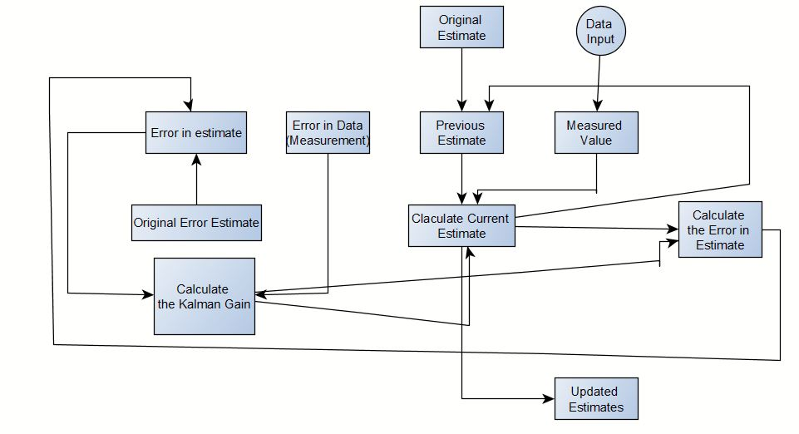

1. -Kalman filter model
2. Recording & Signal Conditioning

Muscle tissues conduct electrical potential similar to the way nerves do, and these electrical impulses are called action potentials. The EMG signal is a signal that provides us the knowledge of electrical currents generated in muscles during its contraction representing neuro-muscular activities. The nervous system controls the contraction and relaxation.

Seven sets of information were recorded with lengths two, 5, and 10 minutes.   
The experiment was supposed to record electromyogram activity from the left arm alongside joint angles at the same time. within the initial four   
datasets, we have a tendency to recorded electromyogram signals from striated muscle alongside joint angle of the arm during a two-dimensional plane within the x- and y-axis directions.

The EMG signal is complicated. Generally, these signals face many disturbances both due to external and internal factors which are known a noise. Noise is something that is not desired in a pure EMG signal. The point of interest of the signal is the amplitude, which has a range between 0 to 24 millivolt (peak to peak). The frequency of an EMG signal is between 0 to 520 Hz. However, the usable energy of the EMG signal is between 45 to 160 Hz. Many dependent factors could affect surface EMG. Thus to avoid the distortion of the signal, a signal conditioning unit is incorporated by using a computational algorithm and by training the machine. The EMG signal undergoes through a Fast Fourier Transform and shifting all the zero components towards the center after adjusting the zero center frequency range because the spectrum of a real signal is about the origin, we prefer to see the spectrum like this, i.e., the zero frequency in the center. Though, when computing the spectrum by FFT, what in the center are in the high frequency. The band-pass filter is then after designed according to our required cut-off frequency. Here we have kept the range in between 5 and 10 and to acquire the index of -5 to -10 and 5 to 10 and to set the cutoff1, cutoff2, cutoff3 and cutoff4 in the required ranges of high and low pass we compute this acquired signal from the bandpass filter to get the inverse Fourier Transform and then after inverse drifting all the zero components away from the center. The obtained signal is computed for the best fit value through convolution by using Mean Average Value theorem and grouping together for future inheritance by K-clustering algorithm throughout the length of the entire signal resulting from obtaining the entire noise-free, distortion, and disturbance-free ECG signal.

The final comparative signal gives us a result output with min contractions, max relaxation, and the exact comparative response.

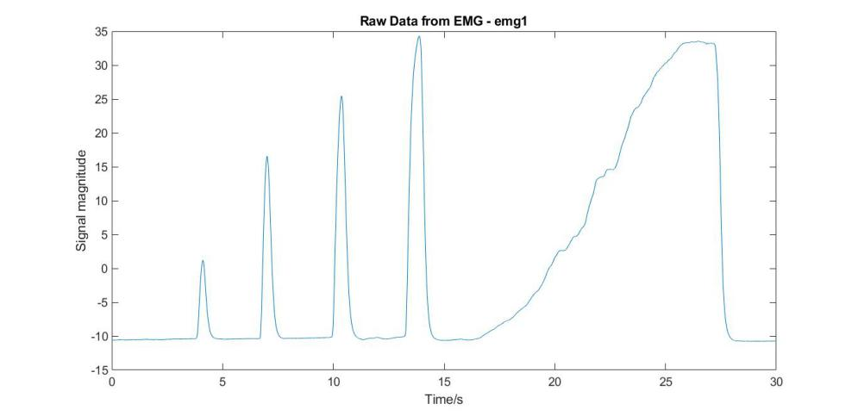

1. -Raw EMG data

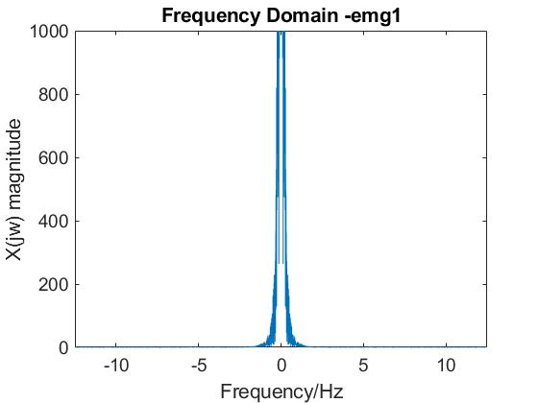

1. -FFT and shift

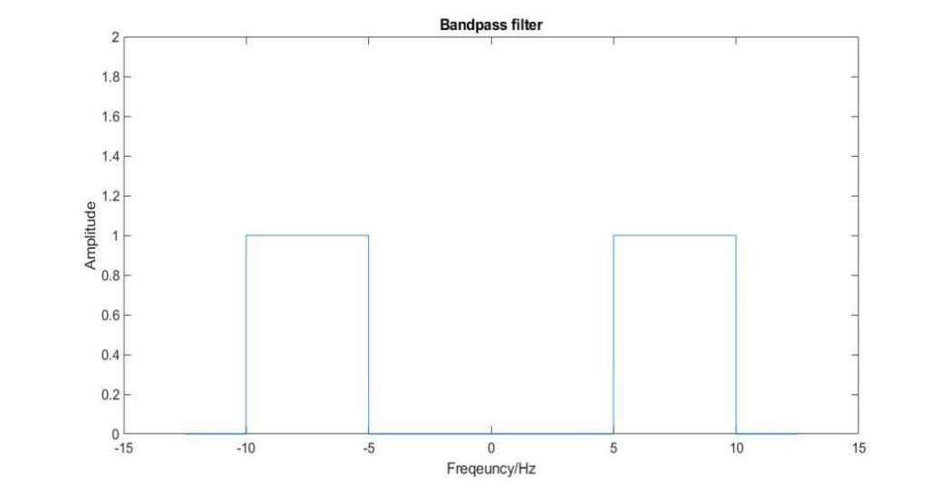

1. -Bandpass Filer design

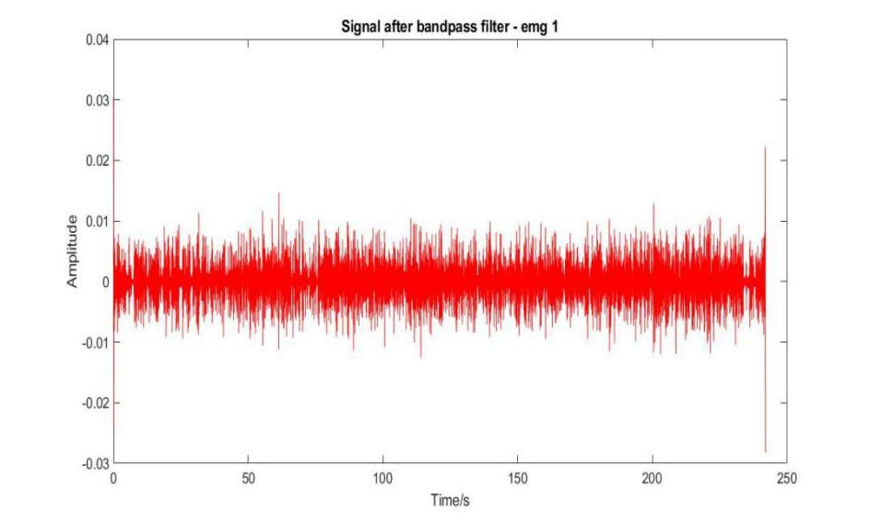

1. - EMG filter signal after passing through a bandpass filter

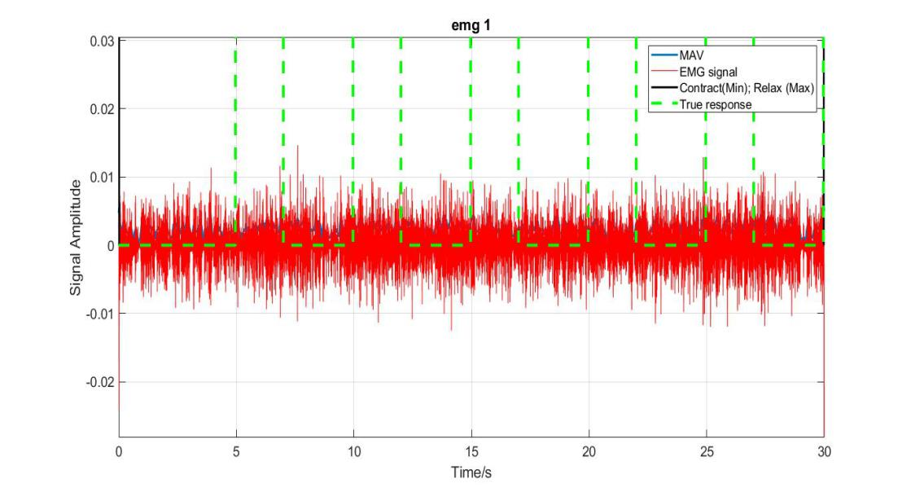

1. - Steady comparative EMG signal with max and min contractions and most fit region

Let us take -

(θm =A)-The armature output angle

AR - The armature resistance

AL - The armature inductance

Eb(t)- The Armature voltage

Va(t)- The Input voltage

Ia(t)- The output armature current



The Transfer function after Laplace transformation is -



Here we do not include gear-ratio as there is no load in the entire process and we are making use of the EMG signal to control the armature

Taking ideal case AL = 0



For analysis, we are taking AR as 2.7 ohms and Kb as 1.3



Now for stability analysis, we are going to make use of root locus.

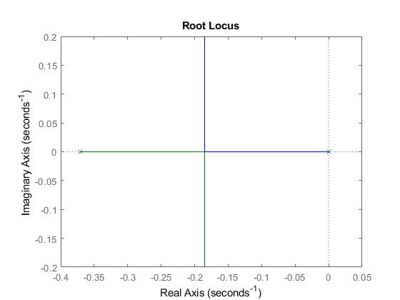

1. -Root Locus

The graphical analysis shows we have two poles one at 0 and another at -0.412, with two Asypmtoes with respective angles of 90 and 270 where the center for Asymptotes is at -0.206. The breakaway point exists at -0.185, with an equation of 3.51s2+1.3s+K. With K> 0.

 3.51 K

s1 1.3 0

s0 K

No K marginal stable system. Based on which it proves that depending on the voltage input, the stability can be decided; hence, it has oscillating stability.

Cross-Analysis

Three decoding schemes were implemented different training and testing conditions:

• Within-session decoder (WS): This decoder was trained and tested with information from an equivalent session. It was enforced so as to own a metric of however suitable our decoder might work. Since we tend to collect data throughout 2 sessions, we tend developed 2 forms of decoders: one victimization solely information from the first session SE1 (WS1) and therefore the different one solely with information from the second session SE2 (WS2).

• Session-to-session decoder (SS): This decoder was trained and validated within the 1st session SE1 and tested within the next session SE2. A performance drop due to the session-to-session transfer was expected when examination its performance to the one in all the WS decoder.

• Re-calibrated session-to-session decoder (RSS):  
This decoder was kind of like the SS decoder explained on top of with the distinction that many minutes of data were collected at the start of S2 in order to re-calibrate the decoder. This was helpful in order to examine if this re-calibration section might  
compensate for the expected performance drop due to the session-to-session transfer.

The modified signal is passed through the model system and is analyzed in with the help of bode plot under frequency domain analysis.

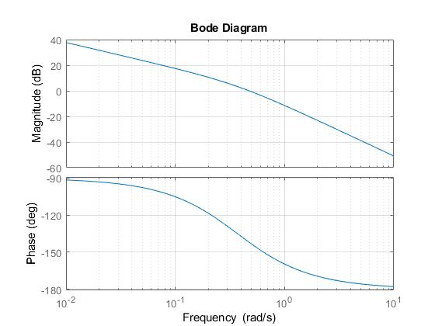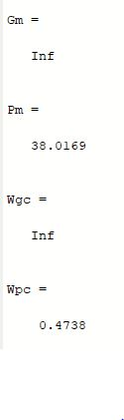

1. -Bode plot Diagram

The analysis provides us with the results that the gain margin is infinite and the gain cross over frequency also tends to infinite, but there is an excellent phase margin value of 38.0169 and phase crossover value of 0.4738. Any system having gain cross over frequency of infinity is of maximum stability and with least disturbances and interference. Hence our system stability got proved.

Kalman Filter-



Kalman Filter takes input from a particular situations within a particular time intervals and helps us to predict how much of the prediction and measurement is required to be imparted in the next new prediction in next interval, the Kalman filter minimizes the error we may have in standard measurements and helps us in predicting the most accurate value .

A Kalman filter models the system by the following three main sets of the equation:-

 The Kalman range always be 0<KG<1

ESTt = ESTt-1 + KG[MEA - ESTt-1]

EEST(t) = [1-KG] (EEST(t-1))

If the KG is large EEST is large than EMEA, therefore we take a lot of the difference (MEA - ESTt-1 ) in consideration, however if the KG is small that means the EMEA is large hence we need a minimal adjustment in the difference (MEA - ESTt-1 ) because we can’t trust the measured voltage also as there is a large uncertainty in the measured voltage also.

That means if the KG is large, then this EMEA is very small that means when there is a new voltage data put in, it can take us very fast to the actual value. Hence there are minimal data variations in voltage.

However, if the EMEA is large, we will not slope down the EEST very quickly, rather than we want to very slowly slope down to the actual value considering multiple data points. In all cases, we will notice that the EEST(t-1) will get small over time.

X0,P0

↓

Xk-1, Pk-1

↓

Xkp = AXk-1+BVk+Wk, Pkp = APk-1AT+Qk

↓

, Xk = Xkp+K[Y-HXKP] ← Yk = CXkM + Zk

The initial state consists of a state matrix(X0) and a process covariance matrix(P0), here the state matrix contains the voltage values which is typically a one dimension matrix, but it can be two-dimension or three-dimension also. The process covariance matrix(P0) is keeping track of the error in the process as we go through the process the current state becomes the previous state. The Xkp and Pkp are the new state predictions where Vk is the control variable matrix which is current conversion in this case and then comes the predicted state noise matrix Wk, and process noise covariance matrix Qk with the help of all this matrix the matrix A and B can be changed from one state to another.

Then we are going to add the measured value with Xkp and Pkp which is having some amount of noise Zk added in it which may be controllable or not depending on different factors, and then we come up the Kalman gain K, this Kalman Gain decides what percentage of Measured value and what percentage of predicted value it is going to take under consideration to update the new state. The Kalman gain takes the process covariance matrix and the vector R, which is sensor noise covariance matrix to predict the new state.

K,Xk → Pk=(I-KH)PkP , XP → Xk,Pk

Now here we do an update on the process covariance error matrix, then we get the new output and new error prediction, this state again becomes the next state, and the process keeps on continuing until and unless we get the minimal error.

Manual calculation -

|  |  |  |  |  |  |  |
| --- | --- | --- | --- | --- | --- | --- |
|  | MEA | EMEA | EST | EEST(t-1) | KG | EEST(t) |
| t-1 |  |  | 68mv | 2 |  |  |
| T | 74mv | 4 | 71.33mv |  | 0.34 | 1.33 |
| t+1 | 71mv | 4 | 70.50mv |  | 0.27 | 1.00 |
| t+2 | 70mv | 4 | 69.40mv |  | 0.24 | 0.8 |
| t+3 | 73mv | 4 | 72mv |  | 0.166 | 0.66 |

Here from the table, we can see that after the implementation of the algorithm we get that there is a reduction in the error estimate with increasing time intervals.

Results-

To test our model we first tested our system using step response as the standard signal Same in the event that we structure the control framework for something like a mechanical actuator: the transient reaction is frequently more significant than exchange work, you'd need to maintain a strategic distance from overshoot, dodge intemperate slew rate, have excellent damping, things like that. Step reaction demonstrates this in a straightforward manner, while move capacity won't (instead, it gives more knowledge into security, and so forth).

Hence after passing the standard test signal through the system, we got the conclusion that the system model is stable.

Then we passed the filtered signal from the Kalman filter through the model using the maximum contraction and minimum contraction values of the signal we analyzed the entire system to measure the error in the system and the stability of the system. After a detailed analytical study, we concluded that our system provides a very stable output with the least possible hindrance in it, and the correlation values between the output and input of the system verify that.

-0.0038 0.0006 0.0045 0.0026 -0.0020 -0.0063 0.0013 0.0070

-0.0006 -0.0027 -0.0022 -0.0017 0.0038 0.0049 -0.0017 -0.0088

-0.0004 0.0103 0.0018 -0.0068 -0.0040 0.0022 0.0073 0.0011

-0.0061 -0.0041 0.0023 0.0061 0.0022 -0.0062 -0.0057 0.0046

0.0050 0.0001 -0.0038 -0.0062 0.0025 0.0085 0.0010 -0.0083

0.0000 0

The correlation values after a detailed study verify that there are very minor fluctuations, the last values are zero hence it proofs that there is almost zero disturbance in the system.

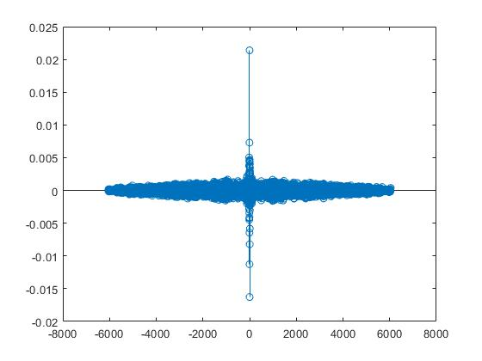

The graph satisfies the all the values are concentrated towards the center of the plot, and very few data points are away from the center, which satisfies that the system is stable.

r1 =

1.0000 -0.7032

-0.7032 1.0000

Here in the dimensional format of cross-correlation coefficient, two matrix points are constants, and two are having a very less fluctuation of about 0.3, which satisfy that the entire system is multi-dimensionally stable.

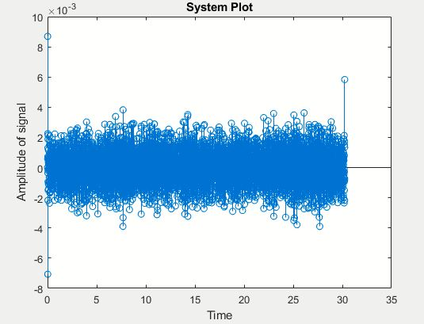

The system plot above plots all the correlation values in a signal plot, from which we can conclude that very few points are there which are deviating out from the central values hence there is very minimal error.

Future Scope-

In addition to electromyogram signals, EEG, EOG and MMG signals also represent the human motion intention and these is used as input signals to the controller of the helpful robots. Accordingly, within the future a hybrid management rule is developed with a mixture of 2 or a lot of biological signals as inputs to the controller. helpful robots area unit expected to operate and seem as their biological counterparts. That is, associate degree systema skeletale ought to ideally act as a second skin for the human and a prosthesis identical